Getting Started

Installation
AppLife Update is distributed as a single windows installer executable. Running the installation executable will place all of the components that make up the AppLife Update solution onto your computer.
The latest software setup files can be downloaded from http://www.kineticjump.com/downloads.aspx

Installing AppLife Update
- Run the AppLife Update Setup msi file
- Generally you can accept all the default options. You can choose to install the AppLife Update application to a different folder.

Note: The administrative privileges are required to install AppLife Update.

Upon installation, AppLife Update will operate fully featured for a period of thirty days. To use AppLife Update beyond thirty days, you must purchase a user license. You can purchase a license online at http://www.kineticjump.com/buy.aspx

Quick Starts
Welcome to AppLife Update! AppLife Update provides incredible flexibility in implementing an update process within your software application. You can choose from four built-in ready to use update processes, or take advantage of the flexibility provided by the AppLife Update API and easily develop your own updating user experience. With your application updating process looking and behaving the way you want, the actions that you can utilize in maintaining your deployed installations from one version to the next is just as flexible. Many common .Net application updating activities, such as file and registry manipulation, come ready-to-use. Just drag, drop and configure them in your action list. And if you don’t find a built-in action that meets your needs, you can use the Dynamic Code Action to write your own .Net updating code, or create your own reusable custom actions. We’ll show you how.

Within this Quick Start guide, we demonstrate how to integrate AppLife Update into your applications, as well as customize AppLife Update to meet your specific updating requirements.
- Simple
The simple quick start application implements the AppLife Update solution in its simplest form. We enable a brand new WinForms application for updating with AppLife Update. This implementation might just be all that you need.
- Simple – WPF
The simple WPF quick start uses the AppLife WPF updating control to implement updating features into a WPF application.
Custom Forms
The Custom Forms application utilizes methods and events on the Update Controller to check for, download, and apply an update. The application replaces the built-in updating user interface with a completely custom one. The tasks that you learn in this quick start can be used to design and implement many different updating processes.
- Custom Actions
This example demonstrates how to create a custom action, as well as a corresponding custom action builder and custom action editor to provide an Update Action that will perform a text file search on the deployed client that is being updated for a designated regular expression. The results are then further manipulated with customized .Net code using a Dynamic Code Action.
After you have reviewed these quick starts, you will be well prepared to implement AppLife Update into your own applications. Please refer to this help manual in its entirety, as well as the AppLife Update API reference, which can be accessed through the AppLife Update Help menu, for more information on using the AppLife Update product to integrate an update process, and deploy software updates into your own applications.

More how-to information and helpful hints can be found online at http://www.kineticjump.com/Forums
To work through these quick starts, you will need to have AppLife Update and Visual Studio installed on your computer.
If you have not already done so, install AppLife Update to your local system.

NOTE: All of the Quick Starts come with a precompiled version 2.0.0.0. This precompiled version is located in the CurrentVersion folder. The update location in the precompiled version does not match the location to where you extracted the Quick Start. As a result, after successfully updating to version 2.0.0.0, subsequent check for update attempts will result in a message that the update location can not be found. To correct this in your Quick Start, change the Update Location on the Update Controller within the Visual Studio project to match the Update Location of the Make Update project.

Extracting the Quick Starts
The Quick Starts are packaged with the install of AppLife Update. You can extract any of the Quick Starts into a new folder by selecting a Quick Start from the Start Page or the Help > Quick Starts menu.

Once extracted, the extraction location will contain a completed Visual Studio project, a corresponding AppLife Update project, and an updates folder with a compiled update ready to go. You can open the Visual Studio project and the AppLife update project file to view the completed quick start. This solution can act as a reference as you read through this accompanying documentation.

Simple Quick Start
The simple quick start application implements the AppLife Update solution by using the UpdateDisplay Windows Forms control. We’ll walk through enabling an existing WinForms application for AppLife Update. To update the application, a single Add and Replace files action is used.

- Add an UpdateDisplay Control to the Main Form of the Application.
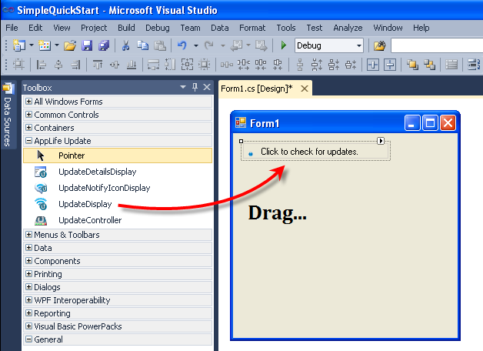
Drag and drop an UpdateDisplay control from the WinForms toolbox in Visual Studio onto the application’s main form. This control can be found on the AppLife Update tab. The UpdateDisplay control provides an in-line asynchronous check for updates, download, and user notification. The control also has a details pop-up pane. You can use this control from the main form of an application to completely manage the update process. There are many customizations available through the properties of this control. When an UpdateDisplay control is placed on a form, an UpdateController control is also added. The Update Controller performs all of the actual work of the update process, and the UpdateDisplay provides a user experience. You can switch user experiences by adding one of the alternative display controls and assigning the existing update controller to the control’s UpdateController property. Multiple visual controls can utilize the same update controller.
See the User Experience Options topic for information on the other built-in update user experiences available.
Note: Visual Studio Express Editions will not have AppLife Update controls pre-populated in the toolbox. These controls can be manually added to the toolbox, and then dragged onto your form. To manually add the controls, select to Choose Items… from the toolbox context menu, then select the UpdateDisplay control from the .Net Framework Components list.
- Set up a new AppLife Update project.
Click the UpdateDisplay control smart tag, and select to Set up a new project.
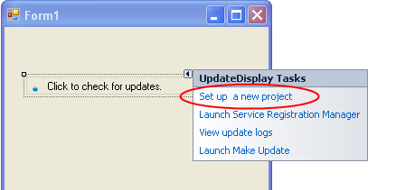
To set up a new project, specify:
- Where will your updates be hosted?
- How would you like to control versioning?
- Will your updates require permissions elevation?

You can utilize any http, ftp, UNC or file path location to host your updates. There are no server requirements, except that your application must be able to connect to this location.
Note: It is common to use a different path to publish updates. Ftp is commonly used to publish, while http is used to retrieve updates.
By using Assembly Version for versioning, the host executable assembly version determines the client version, and is used to determine which updates are available for the application. By selecting to set the version manually, the Version property of the Update Controller will determine the version of the client. Using manual versioning is often used in customized updating implementations to provide flexibility. For most .Net applications, assembly versioning is the best choice.

The permissions that your update process requires is determined by where the application is installed on the deployed system, and the security posture of the deployed system environment. Applications that are installed into the Program Files directory and started by a user with limited permissions will not be able to be updated without permissions elevation. You can choose no elevation, UAC elevation, or elevation using the AppLife Update Windows Service. The AppLife Update Windows Service can securely elevate the permissions of the update process to run as the local system account, allowing limited users to update your software without administrative support. If you utilize the Windows Service, this service will need to be deployed with your application. Administrative permissions are required for initial installation of the service as well as the registration of each application that will use it. See deploying the AppLife Update Windows Service for more information.
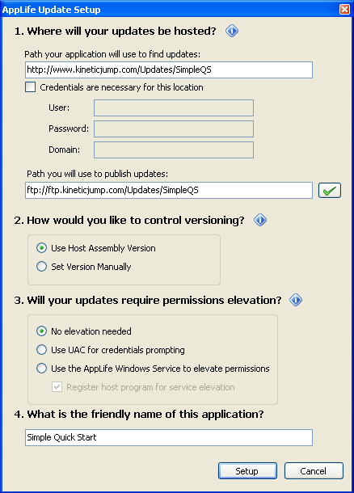

- Build an Update
When you complete the setup, a new AppLife Update project is created, and the Update Controller on the application main form is synchronized with this project. This can be confirmed by comparing the Application ID, Public Key, and Update Location properties of the Update Controller with the project settings. These settings must match in order for your application to successfully apply updates created by this project.
As this project was created, an Add & Replace Files action was added to the project for you. This update action will replace the host executable, and any Visual Studio project referenced assemblies from the solution as the update executes on deployed systems. You can add additional files to this action, or use any other update action in the Action palette by modifying the action list.
To build an Update:
  - Build the executable in Visual Studio. Don’t forget to set the proper version number before building the executable. Make Update will detect the assembly version of the host executable (your application), and this will determine the version number of the update being created.
  - In Make Update, Click the Create an Update button…
This will launch the create update wizard.
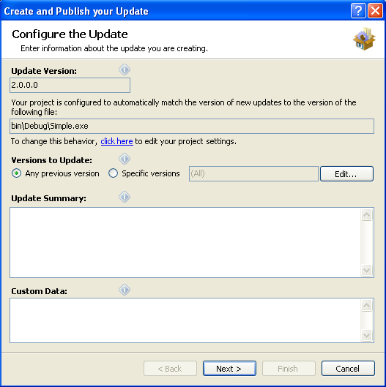
The update version being created is 2.0.0.0. This is detected from the host executable.

This update is available for any previous version of this application. If the actions in the update action list are configured to expect a specific version, you can change the Versions to Update to target a specific version. You can also target all versions greater than a specific version, or a discrete list of previous versions.

Summary text describing the update can be provided. This text will be displayed by the update user experience and is also available through the Update Controller API.

Custom Data provides a method to pass information to your update process. Information provided here is available to your application through the Update Controller API.

Note: The list of versions to update, summary text, and custom data can be modified after an update has been created by managing the update location that the update is published to.

Click Next>
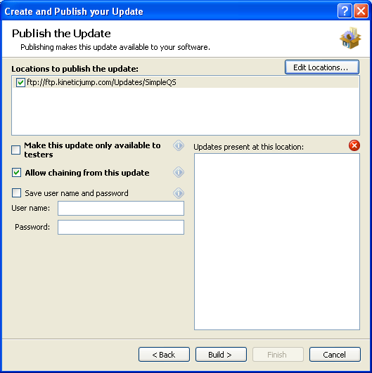

On the next page, you can select from one or more update locations to publish the update to. If your update location requires credentials, you can provide them here, or be prompted as the update is actually transferred. When updates are present at the location, they are displayed in the list on the right.

The update can be designated as a test update by checking the Make this update only available to testers checkbox. When this box is checked, clients who will discover this update must have a specific value in their app.config file. See Testing updates for more information. This value can be modified by managing the update location that the update is published to.

Click Build > to build and publish the new update.

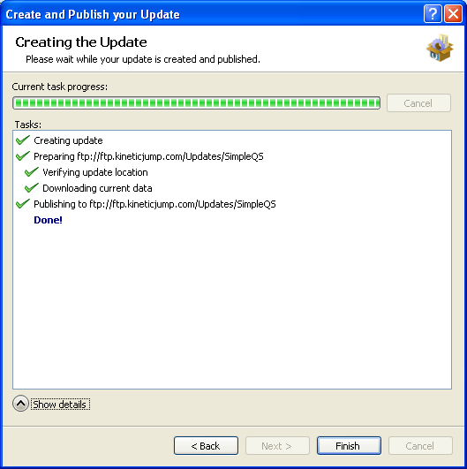

- Applying the New Update
The newly created update can now be used to update any previous version of the application to version 2.0.0.0. To test this, we’ll change the application version in Visual Studio back to version 1.0.0.0, build the application, and then run it.

  - Change the assembly version back to 1.0.0.0
  - Start debugging the application in Visual Studio.
The update process is started automatically.

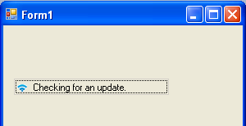

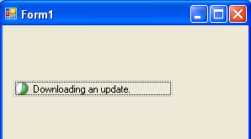

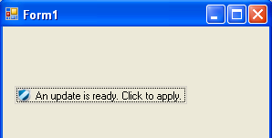

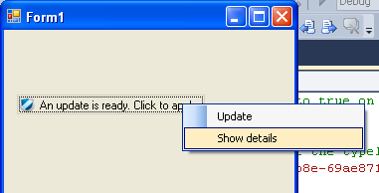

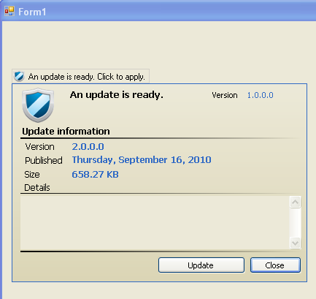
Applying the update…

The host application is closed and the AppLife Update engine performs the actions defined in the update action list.
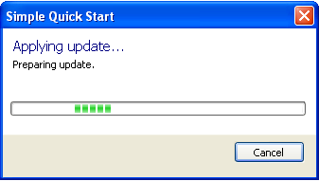
The update completes and the host application is restarted as version 2.0.0.0. An update check is performed, but this time the application is up-to-date.

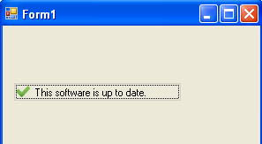

The Custom Forms Quick Start walks through using the Update Controller API to create a completely customized user experience.
The Custom Actions Quick Start walks through creating completely custom update actions, allowing you to perform any updating activity during an update.

Custom Forms Quick Start
The Custom Forms application utilizes methods and events on the Update Controller to check for, download, and apply an update. The application replaces the standard update engine user interface (displayed to the end-user as an update is being executed) with a completely custom UI. The concepts that you learn in this quick start can be used to design and implement completely customized updating user experiences.
This Quick Start does not use any built-in user interface forms at all. It includes totally custom forms that utilize the methods and events of the Update Controller to perform all of the update related tasks. Specifically:
- A custom check for updates form
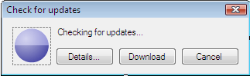
This form uses the CheckForUpdateAsync method and the CheckForUpdateCompleted event to check for updates.
- A custom download updates form
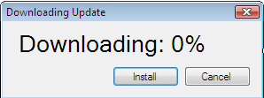
This form uses the DownloadUpdateAsync method, The DownloadUpdateProgressChanged event, and the DownloadUpdateCompleted event to download a discovered update.
- Once downloaded, a button is enabled that allows the user to apply the update.
- A custom Update Engine user interface form
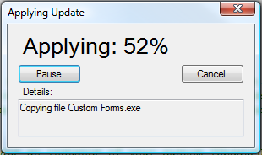
This form is displayed by creating an assembly that includes a class that implements the Kjs.AppLife.Update.Engine.Core.IUpdateUI interface.

Enabling the Application
The application is enabled for updates by following the same procedure outlined in the Simple Quick Start. You add an Update Controller to the host application source code, and then use the Set up a new project utility. If you have not yet reviewed the Simple Quick Start, we recommend that you do so before continuing.

Coding the Update Process
Instead of using a built-in user experience as we did in the Simple Quick Start, a custom user interface is implemented here.

- Create a folder under My Documents and name it Custom Forms.
- Extract the Custom Forms Quick Start in your preferred language by clicking on the link on the AppLife Make Update start page or the Help > Quick Starts menu.
- Open the CustomForms.sln Visual Studio solution.
- Start the solution. When the main form opens, click the Check for Updates button. You will see that the entire user interface of the update process is completely customized.

Checking for Updates
The AppLife Update Controller provides synchronous and asynchronous methods to check for updates. Both methods perform an update discovery task by checking the designated update location for updates. If an update is available for the current version, the CurrentUpdate property of the Update Controller will contain an UpdateInformation structure with information about the available update. If an update is not available, the CurrentUpdate property will be empty or null.

The synchronous CheckForUpdate method returns true if an update is found.

The asynchronous CheckForUpdateAsync method will raise the CheckForUpdateCompleted event when the check is complete.

From AppLife Make Update, click on Help>API Reference and browse to:

<OBJECT id=hhctrl type="application/x-oleobject"
classid="clsid:adb880a6-d8ff-11cf-9377-00aa003b7a11"
codebase="hhctrl.ocx#Version=6,0,6001,18000"
width=100
height=100
>
<PARAM name="Command" value="ShortCut">
<PARAM name="Button" value="Text:AppLife Update API Reference">
<PARAM name="Item1" value=",..\API Help\Kjs.AppLife.Update.API.chm,">
</OBJECT>

Kjs.AppLife.Update.Controller Namespace
UpdateController class
UpdateController Methods
CheckForUpdateAsync Method

Review the documentation for this method. This is the method this Quick Start uses.

- In Visual Studio, open the Form1 source code file of the Custom Forms project. The Check For Updates button handler contains code that opens the custom CheckForUpdatesForm
- The CheckForUpdatesForm contains the relevant code that performs the update check using the Update Controller.
In the constructor of the form, we subscribe to the CheckForUpdateCompleted event and we call the CheckForUpdateAsync method.
- Once the form is opened and before the CheckForUpdateCompleted event occurs, an animated gif is displayed to the user. The user can cancel the check or close the form. The Download button is disabled until an update is found.
You can cancel an ongoing asynchronous operation by calling the UpdateController.CancelAsync method.
- Looking at the mUpdateController_CheckForUpdateCompleted event handler, we can see that we interrogate the CheckForUpdateCompletedEventArgs to determine the results of the update check. First we see if the operation was cancelled, then we look for any errors that might have occurred. If all is good, we can look at the Result property. If an update was found we enable the Download button and do some work to show the user what was found. Notice that we look at the CurrentUpdate property of the Update Controller. If no update was found, the Current Update property would be empty or null.
This event handler is guaranteed to be executed on the same thread that started the asynchronous check. You don’t have to worry about any thread marshalling when using these asynchronous methods. That is all done by the Update Controller.
Notice how little work that was actually involved with the update process. Most of the code that is present involves handling the form and how we want to interact with the user.
One more item to note is the UpdateFound event. Though not used in this Quick Start code, this event allows you to interrogate the update information, and use local client state information, such as your application licensing status, in order to select from alternate updates that might be available. The update can also be canceled, which prevents an update from being discovered. The AppLife Update API documentation contains more information on this event.
Now let’s go download the update.

Downloading an Update
Once an update is found, the CurrentUpdate property contains all the information we need to download, validate, and apply the update.
The Download Update button click handler instantiates and shows a new DownloadUpdateForm.
- Look at the constructor of the DownloadUpdateForm. Much like the CheckForUpdate form, we subscribe to events and call an asynchronous download method. This time we subscribe to an additional event that sends download progress updates.
We subscribe to the DownloadUpdateProgressChanged event and the DownloadUpdateCompleted event.
Then we call the DownloadUpdateAsync method.
- When a progress event occurs, we update the text of the information label on the form. Again, this handler is guaranteed to execute on the calling thread, so as long as the initial DownloadAsync method was called on the UI thread, you can safely modify UI controls. The thread synchronization work is done for you in the Update Controller.
- When the download completed event is handled, much like when the check for update was completed, we check to see if the operation was cancelled and check for any errors. Once the update is downloaded, the controller can validate and apply the update. With the download completed and validated, we enable the Install Now button.

Validate & Apply the Update
Validating the downloaded update uses the public key from the Update Controller and the signature of the update package contained in the Director to check the downloaded update package. You can perform validation manually using the UpdateController.ValidateUpdate method.
The downloaded update can be applied using the ApplyUpdate method. This method also performs validation prior to execution of the update.
Applying an update shuts down this instance as well as all other instances of the application being updated so that its files and assemblies can be replaced. Though this Quick Start does not do so, you can subscribe to the UpdateStarted event of the UpdateController. This event will be raised on every running instance of the hosting application. You can perform any work necessary prior to shutdown, and you can cancel the update from any instance of the application. If all instances cannot be shutdown, the update will abort itself.

- Look at the installButton_Click method. Notice that we validate the update manually before calling ApplyUpdate. Alternately you could call ApplyUpdate and catch any Kjs.AppLife.Update.Controller.ValidationException exceptions.

Like the Simple Quick Start, the AppLife Update project uses the Add & Replace file action to replace the single CustomForms.exe file.
- To customize the Update Engine user interface, we will create a new .Net assembly (.exe or .dll) and create a class that implements the Kjs.AppLife.Update.Engine.Core.IUpdateUI interface. Notice the Custom Update UI project in the quick start solution.

From AppLife Make Update, click on Help>API Reference and browse to:

<OBJECT id=hhctrl type="application/x-oleobject"
classid="clsid:adb880a6-d8ff-11cf-9377-00aa003b7a11"
codebase="hhctrl.ocx#Version=6,0,6001,18000"
width=100
height=100
>
<PARAM name="Command" value="ShortCut">
<PARAM name="Button" value="Text:AppLife Update API Reference">
<PARAM name="Item1" value=",..\API Help\Kjs.AppLife.Update.API.chm,">
</OBJECT>

Kjs.AppLife.Update.Engine.Core Namespace
IUpdateUI Intererface
IUpdateUI Members

This interface is implemented by the Form1 class of the Custom Update UI project. The class code has lots of code comments that provide details on the interface and how it is implemented. To summarize:
- The custom user interface is displayed in the IUpdateUI.Open() method
- The user interface is refreshed in the IUpdateUI.Update() method
- Update completion notification is provided from the IUpdateUI.Finish() method.
- The Custom UI informs the Update Engine of its activity by raising events.
- When the User Interface is closed, the Closed event is raised informing the update engine that it’s okay to shutdown and complete the update process.
- The User Interface can cancel, pause or resume the update by raising events.

- The customized user interface is imported into AppLife Make Update, making it available to be packaged into an update. This is accomplished through the project settings dialog. Project -> Settings menu option.
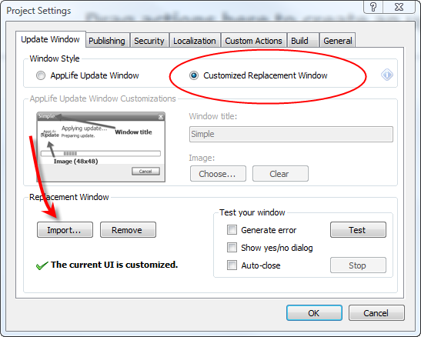
With the customized update engine user interface present, all future updates will utilize the imported user interface.

This Quick Start highlights the manual methods on the Update Controller that allows you to check for, download, and apply updates under a very flexible architecture. A customized update engine user interface was also presented. We used forms to control the process, but no forms are actually necessary. You can mold the update discovery and download features into any visual or non-visual process that best fits your application and your users.

Custom Action Quick Start
This example demonstrates how to create a custom action, as well as a corresponding custom action builder and custom action editor to provide an Update Action that will perform a text file search on the deployed client that is being updated for a designated regular expression. The results are then further manipulated with customized .Net code using a Dynamic Code Action.
Custom actions in AppLife Update allow you to execute custom .Net code during the execution of an update package on the deployed client. Authoring a custom action and adding it to an update consists of:

- Creating a .Net class that inherits from the UpdateAction class
- At a minimum, implement a parameterless constructor, Execute method, and a RollbackExecute method on the class.
- Compile the custom action assembly
- Add the assembly to the collection of custom action assemblies in AppLife Make Update
- Add the action to the project list.

Custom Actions can be further enhanced by creating a custom action builder. With a custom action builder, you can intervene during the update build process, validate the properties of a custom action, manipulate the action properties as the project file is saved, and launch a customized update action editor.

The update scenario demonstrated in this Quick Start is to migrate setting from a text-based configuration file that version 1 of the example application uses, to an xml-based configuration file that version 2 of the example application uses.

- Review how the AppLife Update Engine operates. Our custom actions operate in this context.
- When added to the Make Update custom action assemblies list, our custom actions are configured within AppLife Make Update and persisted within the AppLife Update project file by interacting with public properties on the custom action classes. Any public properties that are implemented will be configurable from AppLife Make Update and persisted with your project.
- Review the Update Context object. We will use the context object’s SharedProperties property to pass information between the actions in this example.

Architecting our Custom Actions
We are going to create a custom action that searches a designated text file for a line that includes a designated regular expression. If the regular expression search finds a match, the entire line within the text file will be placed in a designated Shared Property within the Update Context Shared Properties collection so that it is available for further processing by the update. This custom action is named Search File Action.
Further processing will be performed by a second custom action that is defined within a built-in Dynamic Code Action. Dynamic Code actions provide the ability to quickly create customized update activity.
Our Search File Action is further refined by adding a custom action builder. In the custom action builder, we’ll validate the properties of the action, preventing Make Update from building the action with invalid input information. We’ll also create and launch a custom update editor. Our editor will replace the default property grid editor and provide an intuitive interface as well as validation feedback for the update designer.
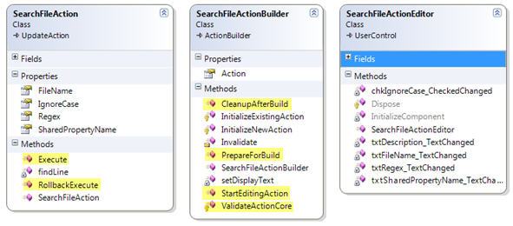

- Open the Custom Actions solution with Visual Studio. Within this solution you will find two projects. The Custom Actions application and the Actions class library.
- Notice that the Actions project contains a reference to the Kjs.AppLife.Update.Engine.Core assembly and the Kjs.AppLife.Update.Engine.Core.Design assembly. These assemblies are located in the [InstallDir]\PublicAssemblies folder where AppLife Update is installed. The core assembly contains the UpdateAction base class from which all custom actions are derived. The design assembly contains the ActionBuilder base class used provide a custom action builder and editor.

Creating the SearchFileAction
The SearchFileAction derives from UpdateAction. It contains an empty parameter-less constructor. This constructor is necessary, as without it, the Update Engine could not create an instance of this action.

There is a public FileName property that is used to store a path (relative to the deployed client application directory) to a local text file that will be searched when the update action executes.

There is a public Regex property that is used to store the regular expression that will be searched for within the identified text file.

There is a public SharedPropertyName property that identifies the key name of the Shared Property that will store the results of the regex search.

Adding these properties makes this action easily re-usable in other projects.

- The Execute method of this action backs up the value of the designated Shared Property (if it exists) so that it can be rolled back if the update fails. Then, the designated text file is searched.
The user is kept informed by utilizing the base class OnProgressChanged method, and the update execution log file is updated using the UpdateContext Log property.
- The RollbackExecute method restores the original value of the Shared Property. No other action is necessary to rollback the execution of this action.
To control the AppLife Make Update palette location of this action, attributes are placed on the class declaration.
[DisplayName("Search File")]
[Description("Search a text file for a regular expression and store the matching line in a shared property.")]
[Category("Files & folders")]
These attributes result in:
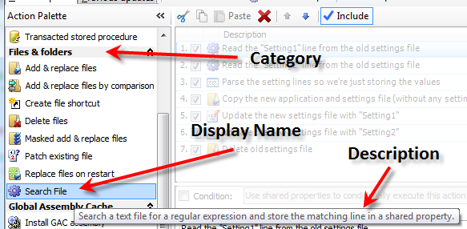
These attributes cleanly present the custom action within the Make Update application, however they are not required. If they were omitted, the action would be in a category named “Misc” with an action name that matches the name of the class.

Creating the SearchFileActionBuilder class
Note: See Custom Action Builder.
Implementing an action builder for the SearchFileAction will provide validation functionality as well as launch a customized action editor user interface. The custom action editor is assigned to the action by adding a ActionBuilder class attribute to the action class.
[ActionBuilder(typeof(SearchFileActionBuilder))]
public class SearchFileAction : UpdateAction {
- Implement ValidationActionCore
This method checks to ensure that a search file name, regular expression, and shared property key name is provided. If any of these properties are empty, Make Update will not build the project, and the action is adorned as being invalid.

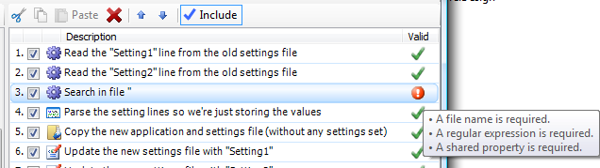

- Implement StartEditingAction
In this method, the custom editor is instantiated and shown, replacing the default property grid editor.
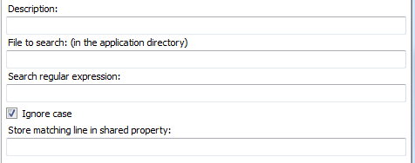

Creating the SearchFileActionEditor
A custom action editor is a Windows Forms User Control. When a custom action editor is created, the corresponding Action Builder instance is passed into the editor as a constructor parameter. We maintain a reference to the Action Builder and by extension, the Update Action. This reference is used to manipulate the Update Action from the custom editor.
The SearchFileAction editor provides textboxes and checkboxes to enter the necessary information required to configure the update action behavior.

Adding the actions to your action list
Once the Update Action and supporting classes are compiled into a .Net assembly, we can add the assembly to the custom action assemblies list.

Open the Project Settings dialog from the Project menu. Then open the Custom Actions tab.
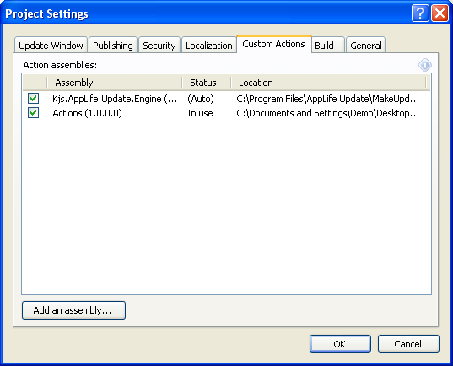

Add an assembly by clicking the Add an assembly button and browsing to your custom assembly.

Note: AppLife Make Update loads the custom action assemblies that are used by the project. When a custom action assembly is loaded, the assembly is locked by Make Update. This could cause Visual Studio builds to fail if you reference your custom action assemblies in Make Update from the Visual Studio build location. To unload the assemblies you will need to close AppLife Make Update.

Once an assembly has been added, its custom actions are placed in the action palettes and are available to be placed into the action list. Custom actions can also be made available globally to all Make Update projects by placing the assembly into the Make Update AppDir/Custom Actions folder. This folder is typically located at:
C:\Program Files\AppLife Update\MakeUpdate\CustomActions

Update the Example Application using the Search File Action
Version 1 of the example application utilizes a text-based settings file. Version 2 utilizes an Xml-based settings file. In order to update a deployed Version 1, our update must migrate a couple of settings from the old to the new settings files. To do this, we are going to utilize the Search File action, along with a few built-in Update Actions.

Step 1 – Find the settings of interest within the old text-based settings file
Step 2 – Parse the settings that are found using a Dynamic Code Action
Step 3 – Copy the new application assemblies and the new Xml Settings file using an Add & Replace files action.
Step 4 – If previous settings were successfully extracted from the existing settings file in Steps 1 and 2, then update the newly placed Xml file using a Change Xml Node action. Note: These actions are conditionally executed.
Step 5 – Delete the old settings file using a Delete files action.

Our update action list looks like this:
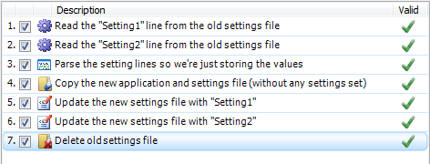

Search File Editor:
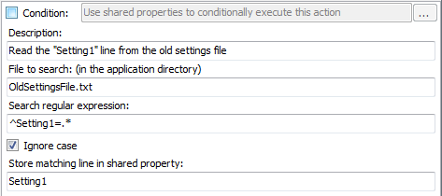
This action will search the OldSettingsFile.txt file for the line that has the Setting1=value, and if found, the entire line will be placed in a Shared Property named Setting1.

Parse the Settings values using a Dynamic Action:
The built-in Dynamic Code action provides a simpler method to add a custom action to an update. To demonstrate this method, a Dynamic Code Action is used to parse the value out of the line that was found by the custom Search File Action.

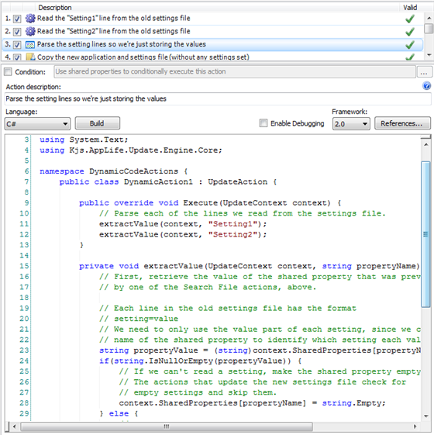
The Dynamic Code action allows you to write a custom action directly within Make Update. The action is compiled as the update package is built. This action will read the Shared Property that the Search File action set, and parse the value. The Shared Property is then updated to include only the value of the setting.

Copy the Application Assembly and new Xml Settings File
A built-in Add & Replace files action places the new files on the deployed client.
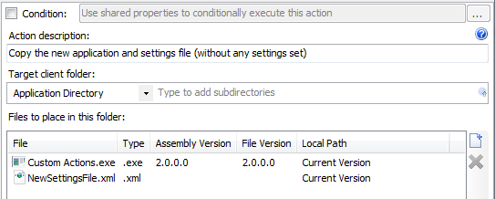

Updating the new Xml File
With the NewSettingsFile.Xml now present and populated with default values, the update must replace the default values with the entries from the previous text-based settings file. To accomplish this, a built-in Change Xml Node action is used.
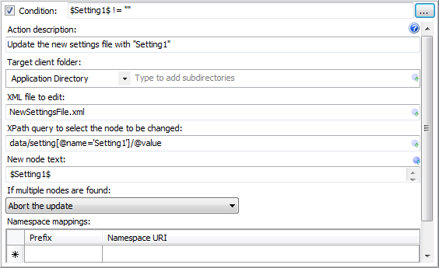

Conditional Execution:
This action has a condition expression set. The action is only executed if the shared property “Setting1” is not empty.

If the Shared Property “Setting1” is not empty, the NewSettingsFile.xml file is updated using an XPath query and the value of the Shared Property.

Deleting the old Settings File
The final step in this update process is to use the built-in Delete File action to remove the old settings file.
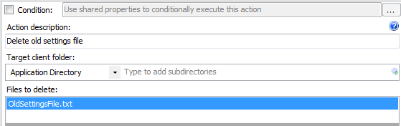

Summary
Creating custom actions for use with AppLife Update is extremely easy. You are not limited to just the standard AppLife Update actions. Custom actions allow you to easily define and execute .Net code during your software updates.
Reference the API Reference documentation

<OBJECT id=hhctrl type="application/x-oleobject"
classid="clsid:adb880a6-d8ff-11cf-9377-00aa003b7a11"
codebase="hhctrl.ocx#Version=6,0,6001,18000"
width=100
height=100
>
<PARAM name="Command" value="ShortCut">
<PARAM name="Button" value="Text:AppLife Update API Reference">
<PARAM name="Item1" value=",..\API Help\Kjs.AppLife.Update.API.chm,">
</OBJECT>

Browse the Kjs.AppLife.Update.Engine.Core namespaces for more information on custom actions.

Simple WPF Quick Start
The simple WPF quick start demonstrates how to utilize AppLife Update within a WPF application. This example utilizes the WPF UpdateDisplay control.

- Add an UpdateDisplay Control to the Main Window of the WPF Application.
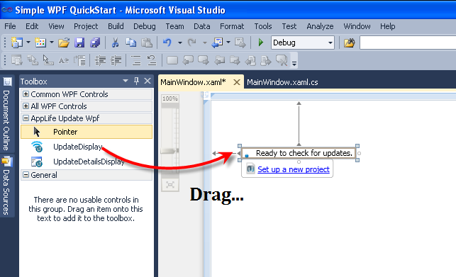
Drag and drop an UpdateDisplay control from the WPF toolbox in Visual Studio onto the application’s main window. This control can be found on the AppLife Update tab. The UpdateDisplay control provides an in-line asynchronous check for updates, download, and user notification. The control also has a details pop-up pane. You can use this control from the main window of an application to completely manage the update process. There are many customizations available through the properties of this control. When an UpdateDisplay control is placed on a window, a reference to the Kjs.AppLife.Update.Wpf.dll and Kjs.AppLife.Update.Controller.dll is added to the Visual Studio project. In addition, a “kjs” namespace is declared on the window.
See the User Experience Options topic for information on the other built-in update user experiences available.
Note: Visual Studio Express Editions will not have AppLife Update controls pre-populated in the toolbox. These controls can be manually added to the toolbox, and then dragged onto your form. To manually add the controls, select to Choose Items… from the toolbox context menu, then select the UpdateDisplay control from the WPF Components tab.
- Set up a new AppLife Update project.
Click the control’s Set up a new project adorner.
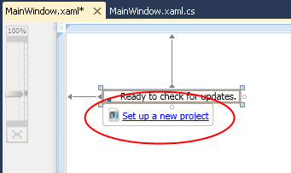
To set up a new project, specify:
- Where will your updates be hosted?
- How would you like to control versioning?
- Will your updates require permissions elevation?

You can utilize any http, ftp, UNC or file path location to host your updates. There are no server requirements, except that your application must be able to connect to this location.
Note: It is common to use a different path to publish updates. Ftp is commonly used to publish, while http is used to retrieve updates.
By using Assembly Version for versioning, the host executable assembly version determines the client version, and is used to determine which updates are available for the application. By selecting to set the version manually, the Version property of the Update Controller will determine the version of the client. Using manual versioning is often used in customized updating implementations to provide flexibility. For most .Net applications, assembly versioning is the best choice.

The permissions that your update process requires is determined by where the application is installed on the deployed system, and the security posture of the deployed system environment. Applications that are installed into the Program Files directory and started by a user with limited permissions will not be able to be updated without permissions elevation. You can choose no elevation, UAC elevation, or elevation using the AppLife Update Windows Service. The AppLife Update Windows Service can securely elevate the permissions of the update process to run as the local system account, allowing limited users to update your software without administrative support. If you utilize the Windows Service, this service will need to be deployed with your application. Administrative permissions are required for initial installation of the service as well as the registration of each application that will use it. See deploying the AppLife Update Windows Service for more information.
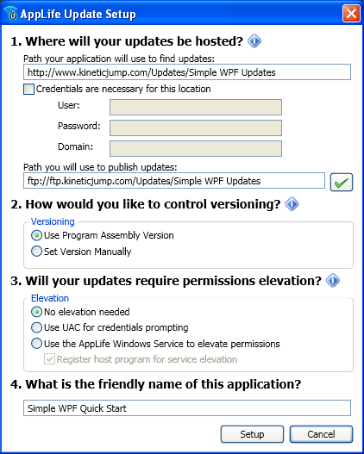

- Build an Update
When you complete the setup, a new AppLife Update project is created, and the Update Controller on the application main form is synchronized with this project. This can be confirmed by comparing the Application ID, Public Key, and Update Location properties of the Update Controller with the project settings. These settings must match in order for your application to successfully apply updates created by this project.
As this project was created, an Add & Replace Files action was added to the project for you. This update action will replace the host executable, and any Visual Studio project referenced assemblies from the solution as the update executes on deployed systems. You can add additional files to this action, or use any other update action in the Action palette by modifying the action list.
To build an Update:
  - Build the executable in Visual Studio. Don’t forget to set the proper version number before building the executable. Make Update will detect the assembly version of the host executable (your application), and this will determine the version number of the update being created.
  - In Make Update, Click the Create an Update button…
This will launch the create update wizard.
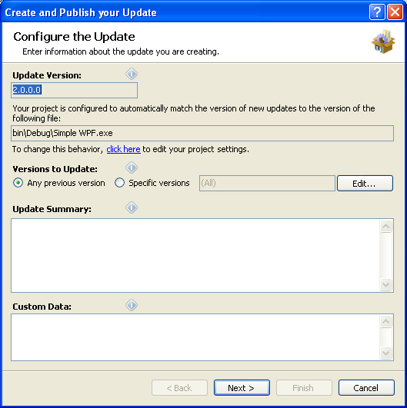
The update version being created is 2.0.0.0. This is detected from the host executable.

This update is available for any previous version of this application. If the actions in the update action list are configured to expect a specific version, you can change the Versions to Update to target a specific version. You can also target all versions greater than a specific version, or a discrete list of previous versions.

Summary text describing the update can be provided. This text will be displayed by the update user experience and is also available through the Update Controller API.

Custom Data provides a method to pass information to your update process. Information provided here is available to your application through the Update Controller API.

Note: The list of versions to update, summary text, and custom data can be modified after an update has been created by managing the update location that the update is published to.

Click Next>
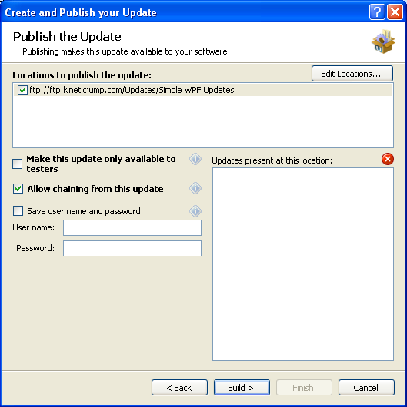

On the next page, you can select from one or more update locations to publish the update to. If your update location requires credentials, you can provide them here, or be prompted as the update is actually transferred. When updates are present at the location, they are displayed in the list on the right.

The update can be designated as a test update by checking the Make this update only available to testers checkbox. When this box is checked, clients who will discover this update must have a specific value in their app.config file. See Testing updates for more information. This value can be modified by managing the update location that the update is published to.

Click Build > to build and publish the new update.

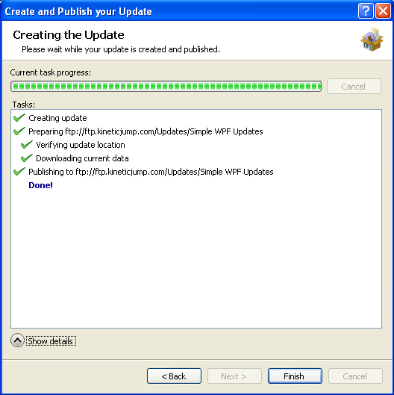

- Applying the New Update
The newly created update can now be used to update any previous version of the application to version 2.0.0.0. To test this, we’ll change the application version in Visual Studio back to version 1.0.0.0, build the application, and then run it.

  - Change the assembly version back to 1.0.0.0
  - Start debugging the application in Visual Studio.
The update process is started automatically.

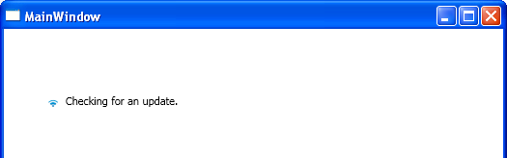

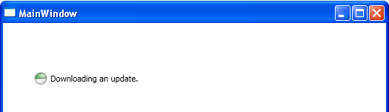

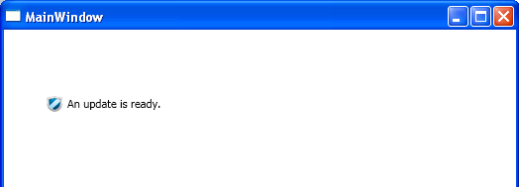

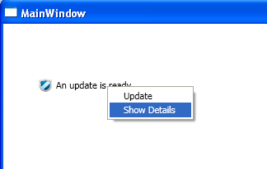

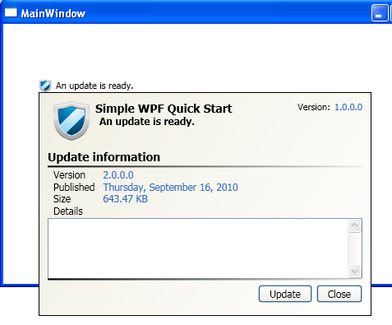
Applying the update…

The host application is closed and the AppLife Update engine performs the actions defined in the update action list.
The update completes and the host application is restarted as version 2.0.0.0. An update check is performed, but this time the application is up-to-date.

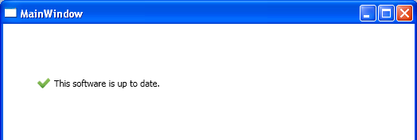

The Custom Forms Quick Start walks through using the Update Controller API to create a completely customized user experience.
The Custom Actions Quick Start walks through creating completely custom update actions, allowing you to perform any updating activity during an update.

License Management
AppLife Update is licensed per builder. A builder is defined as a person or process that interacts to build and publish updates using the AppLife Update tools.
The Update Controller assembly and features can be distributed royalty free with your applications, so long as the updates being created for the application are created by a licensed user.
Our licensing model is based on users who actually build update packages. With AppLife® Update, your costs do not increase with more end users, project developers, or even applications. You simply purchase a license for your team members who build update packages. Furthermore, all licenses include one year of premium technical support and software upgrades.

Single Builder License
An AppLife® Update Single Builder license permits one user to install and use the AppLife Update tools on a single computer. A licensed builder can build updates for an unlimited number of applications. The client components deployed with your software can be distributed royalty-free to an unlimited number of clients.
Limited Licensing
AppLife® Update is a very flexible and feature rich application updating framework that meets the needs of even the most complex application updating challenges. Many applications do not require all of the features that AppLife® Update has to offer. For these applications, we offer a limited license. A limited license grants access to the robust application updating framework within AppLife® Update and file replacement features. When you are ready to customize your update process or take advantage of all of the other update actions available, you can extend your update solution at any time by simply purchasing a full license.
Feature Matrix
General Features | Full | Limited
Complete, built-in update process user interface
Windows Forms Updating Visual Controls
WPF Updating Visual Controls
Comprehensive API to control the update process
Discrete API methods to check for updates
Discrete API methods for downloading updates
Visual Studio Designer Support
Update Execution Log Viewer
Integrate update publishing directly into automated build processes
Localized update process (en, de, es, fr, it, ja, zh-CHT)
Easily integrate your licensing model into the update process
Supports the .Net 2.0 through 4.0 Frameworks (Including Client Profiles)
Full support for Vista/Windows 7 UAC Elevation
Distribution Framework Features | Full | Limited
Use any web or file server
Manage multiple update locations
Download from any ftp, http, https, UNC, or file path
Download updates in the background
Resume interrupted downloads
Publish updates for specific client versions
Provide specific, localized summary information for each update
Publish custom data with each update - Consume data in client code
Choose from all available updates within client-side logic
Download progress indication with option to cancel
Coordinated shut down of all application instances
Automatically detect proxy settings
Control rollout of updates gradually over time
Preserved command line parameters on application restart
Configurable text to display when no updates are available
Flexible determination of current client version
Designate updates with toggle-able limited availability for testing
Dynamic control of update location
Pass custom http header values to web server
Security Features | Full | Limited
Cryptographic update package signature verification after download
Secure download support using SSL (https)
Download and Publish updates from secured network folders
Securely elevate privileges to apply updates for non-admin client users
Update without Vista UAC prompting
Application Update Activity Features | Full | Limited
Maintain client system integrity with transacted update execution engine
Preemptive permission checking to avoid inevitable execution failure
Replace client files in common folder locations
Automatically determine files to include in updates
Automatic Update Chaining
Distribute .Net 4.0 Framework
Easily execute custom .Net code with the Dynamic Code Action
Conditional Expressions on Update Actions
Bitwise File Patching
Comprehensive Update Logging
Add and Remove Assemblies from the GAC
Replace Files on Windows Restart
Register .Net Assemblies for COM Interop
Execute Command Line Activity
Execute MSI's during Update
Pass Client State Info into Update Process
File mask exclusion of files (e.g. *.config, *.pdb, etc.)
Add files by mask (e.g. *.exe, *.dll, etc.)
Create file shortcuts
Register / unregister 32 or 64 bit COM components
x64 File System and Registry support
Update databases using transacted, provider-independent actions
Modify Xml files (including application config files)
Start/Stop Windows Services
Pass variables between update actions
Simple branding and text customization of update engine user interface
Optionally restart application after update
Complete Visual Customization of Update User Interface
Update Summary Spell Checking
Updates can be applied silently
Extensible update infrastructure for creating custom actions
Expansion variables evaluated on the client at runtime

Acquiring and Applying a License Number

After downloading and installing the AppLife Update software, the software will operate fully featured for a period of 30 days. After 30 days you will need to license the software in order to build an update. By licensing Make Update, the AppLife Update command line utility is also licensed.

To purchase a license, go to http://www.kineticjump.com/buy.aspx

After purchasing a license, you will be emailed the purchased quantity of license numbers.

To apply a license number, launch Make Update. From the Help menu, select the License option.

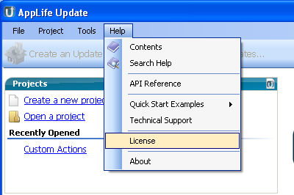

Copy the license number from the email and paste it into the License textbox.

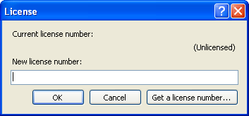

Once your license number has been applied, full build and publish features will be restored. Your license is applied per user. Logging in as a different user will require applying a different license.

Activating your License
Your license must be activated within seven days of being applied in order to prevent interrupting your ability to use the software. If your system is connected to the internet, simply press the Activate Now button presented when you apply your license.

Note: AppLife Update attempts to automatically detect your network proxy settings. If your network requires manually configuring proxy server settings, you may do so under the Tools..Options..Publishing menu.

Manual Activation
If your system cannot be connected to the internet for activation, you may activate your license manually by using a computer that is connected to the internet or by calling Kinetic Jump tech support during business hours.
To activate manually, select the Tools..Activate menu option. Attempt a network activation. When this attempt is unsuccessful, a manual activation dialog is presented. Note your Machine Name and software version number. On a system that can access the internet, navigate to the manual activation URL (http://www.kineticjump.com/productactivation/activate.aspx). Enter your license number, Machine name, and version number into the web form. Save the file downloaded from the activation server and transfer it to the client being activated. Click on the Activation file… button and browse to the transferred activation file.
You will only need to activate your software once.

